
Team Assignment 11
HIT
3/17/2012

Software Measurement and Analysis

Team members: | Members ID
Giang Thị Ha Thanh | T097828
Trần Dũng Đạt | T095716
Nguyễn Vũ Trọng Giang | T096656
Huỳnh Chấn Huy | T096498
Tạ Quang Hiệp | T090363
Nguyễn Trần Hồng Phúc | T095014

Each team analyzes provided Viking customer satisfaction data (Viking Customer Satisfaction Survey Data.xls) and submits a report (<2 pages) on your findings (What is your analysis of the survey results, and what recommendations do you make?)
Viking Customer Satisfaction Report

- Introduction
  - Purpose
Satisfying our customers is an essential element to staying in business in this modern world of global competition. We must satisfy and even delight our customers with the value of our software products and services to gain their loyalty and repeat business. Customer satisfaction is therefore a primary goal of process improvement programs. So how satisfied are our customers? One of the best ways to find out is to ask them using Customer Satisfaction Surveys. These surveys can provide management with the information they need to determine their customer's level of satisfaction with their software products and with the services associated with those products.
This report will analyzes provided Viking customer satisfaction data
  - Scope
We sent this survey to our 5 big customers 4 months after Viking release 1 shipped to find out how they were using the product, and how much they liked it. Each customer's response can be found in their Worksheet.
At the time we sent out the survey we had the 5 big customers and also about 20 small (<20 users each) customers. We chose to not send the survey to the small customers because the large customers have thousands more users so they are who we want to please the most.
  - References
- Viking_Customer_Satisfaction_Survey_Data.xls
- Variable Data Definitions
Gender:
- Male
- Female
Age: Various ages
- Below 18
- 18 – 24
- 25 – 30
- 31 – 40
- Above 40
Five-level “Likert Scale”:
- 5 - Very satisfied
- 4 - Somewhat Satisfied
- 3 - Neither Satisfied nor Unsatisfied
- 2 - Somewhat Unsatisfied
- 1 - Very Unsatisfied
- Summary of Current Satisfaction Levels
  - Important Point Table
No. | Questions | Sections | Point
1 | How often do you use the Viking software? | Frequency | 3
2 | How satisfied are you with your purchase experience? | Purchasing of software | 2
3 | How satisfied are you with your installation experience? | Installation | 1
4 | How satisfied are you with your user experience? | Functionality of software | 4.5
5 | How satisfied are you with your support experience? | Technical Support | 4
6 | Overall, how satisfied are you with our software? | Overall satisfied | 5

  - Satisfy Summary Table
Sections | Customer A | Customer B | Customer C | Customer D | Customer E | AVG
1 | 5 | 5 | 5 | 5 | 5 | 5
2 | 4 | 5 | 4 | 4 | 4 | 4.2
3 | 2 | 5 | 3 | 4 | 3 | 3.2
4 | 4 | 5 | 5 | 4 | 4 | 4.4
5 | 4 | 5 | 4 | 4 | 4 | 4.2
6 | 4 | 5 | 4 | 4 | 4 | 4.2
AVG | 3.8 | 5 | 4 | 4.2 | 4

  - Analysis Reporting Survey Results
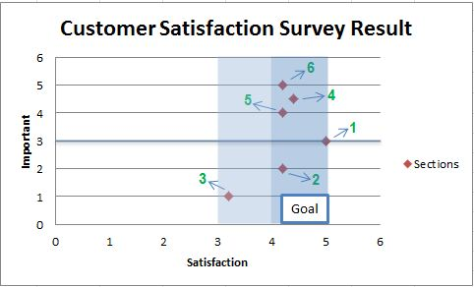
1 - Frequency
2 - Purchasing of software
3 - Installation
4 - Functionality of software
5 - Technical Support
6 – Overall Satisfied
Figure 1: Customer Satisfaction Survey Result
About times of using the Viking software, the chart shows that they are using the software with highest frequency. This will easier to see in Figure 2.
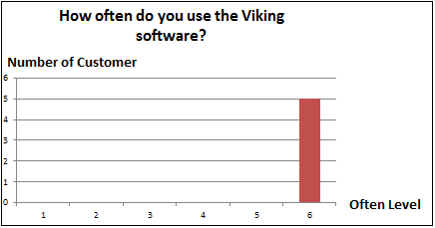
Figure 2: Question 1 summary

Figure 3 show that our purchase process (such as purchasing procedures, payment procedures, the delivery time) was done quite well.
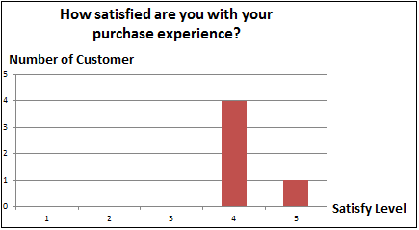
Figure 3: Question 2 summary

The Figure 4 show that not all surveyed customers satisfy with installation process. One of their comments said “many problems with installation”. And their unique environment offered plenty of challenges to our software. Each customer has a different working environment. So we can see that the choice of customers is very different with installation, depending on the adaptation of the Viking for their environment. To satisfy all of them we must increase the important of installation process and research to make Viking adapted to many different environments
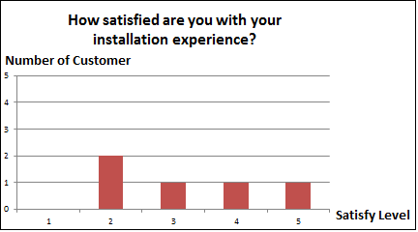
Figure 4: Question 3 summary

Figure 5 shows that our customers are very satisfied with Viking software, one of their comments is: “Problems have been resolved quickly” and “Lots of problems but they are resolved quickly” that mean Viking has been done it job well.
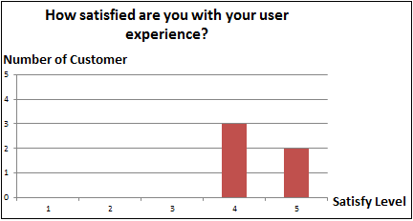
Figure 5: Question 4 summary

Our support process, such as guarantee, maintenance is make customer quite satisfied. Figure 6 show that clearly.
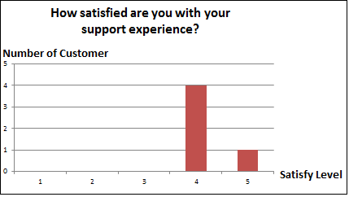
Figure 6: Question 5 summary

Conclusion: Figure 7 show the overall satisfy level of our big 5 customer with Viking software, generally, they are impressed with the product, but based on Figure 1 and Figure 4 we can see our installation are not so good, that mean we must focus on this stage, make Viking can be adapted to more environment and easier to install.
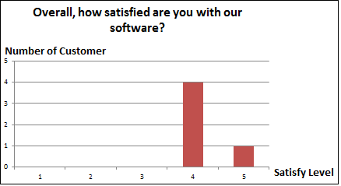
Figure 7: Question 6 summary

